1

Data Management Frameworks: Analyze and create.

Masha M. Stephen

MSDS-533-M20 Data Management for Data Science

Dr. Yehia Mohamed

5/12/2024

2

Data Management Frameworks: Analyze and create.
Data management involves collecting, organizing, storing, and utilizing data to ensure its integrity, accessibility, and security. This field aims to maximize the value of data assets whiles maintaining compliance with regulatory and ethical standards. Strategic Alignment model, The Amsterdam Information model, and the DAMA-DMBOK Framework are the 3 main Frameworks in data management.
The Strategic Alignment Model aligns an organization’s IT Strategy with business strategy. It focuses on the importance of understanding the interplay between an organization’s business strategy, IT Strategy, IT infrastructure, and IT processes. This model promotes communication and collaboration between departments within an organization. However, SAM is complex and requires a lot of resources and expertise. Its effectiveness relies heavily on the accuracy and completeness of the information used to assess alignment (Admin. (2023, June 24)).
The Amsterdam Information Model focuses on defining clear structures for data elements, relationships, and classification to enable data integration, sharing, and governance. This model can accommodate various data types, making it flexible and scalable. It is useful for organizations that want to improve their data consistency, interpretability, and quality. The challenges of implementing this framework are efforts required to map existing data structure, maintain consistency and integrity across complex organizations, and lack of guidance on how to address emerging data management challenges (CIOINDEX. (2023, July 29)).
The DAMA-DMBOK framework involves the development, execution, mitigation of plans, policies, programs, and practices that deliver, control, protect, and enhance the value of data and information assets throughout their lifecycle (Linxiao Ma. (2021, September 17)). It emphasizes data governance, quality, and stewardship, aligning with industry standards and regulations. This framework’s effectiveness depends on organizational culture, maturity, and industry context. It may lack specific guidance on how to integrate data management practices with broader business strategies and objectives.
The choice of framework depends on the specific needs, goals, and context of the organization. Some frameworks may excel in providing comprehensive guidance, while others may prioritize simplicity and practicality. When creating a framework for an organization, one must consider data quality assessment, data valuation methods, performance metrics, analytics, and integration. In a manufacturing company, accuracy, consistency, relevance, and validity will ensure the quality of data. Evaluation of cost approach and income approach will base the value of the framework. Performance metrics can evaluate data growth and return on data investment. Integration and analysis will facilitate data consumption.
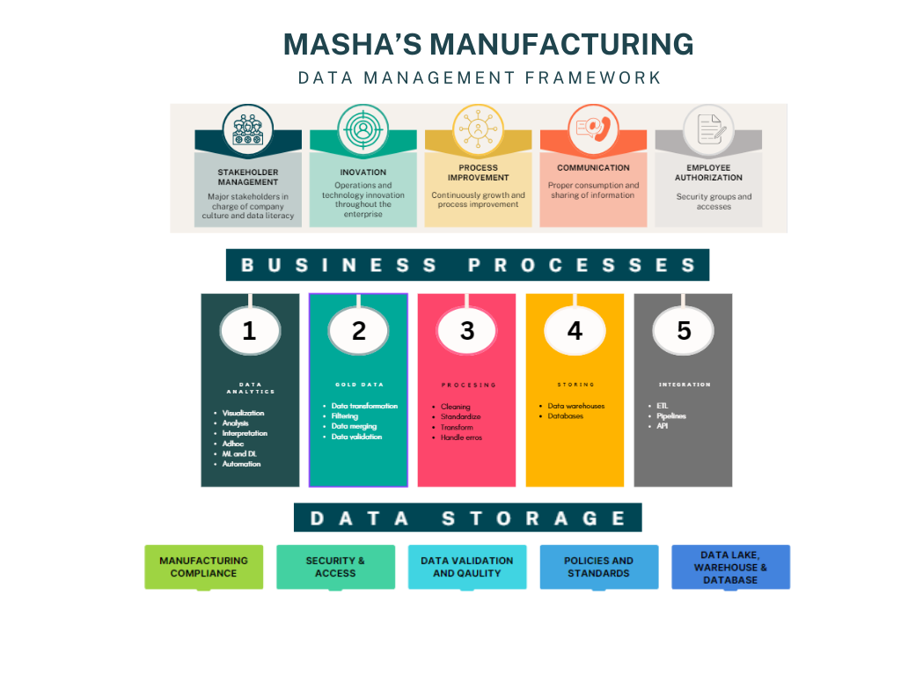

References
Admin. (2023, June 24). Strategic alignment: Explained with examples. The Strategy Story. https://thestrategystory.com/blog/strategic-alignment-explained-with-examples/
CIOINDEX. (2023, July 29). Using Amsterdam information management model (AIM) strategic alignment model. CIO Portal. https://cioindex.com/reference/using-amsterdam-information-management-model-aim-strategic-alignment-model/
Linxiao Ma. (2021, September 17). What is data management, actually? – DAMA-DMBOK framework. Data Ninjago & dqops. https://dataninjago.com/2021/09/15/what-is-data-management-actually-dama-dmbok-framework/

5


University of the Cumberlands

School of Computing and Information Sciences

Certification of Authorship

Submitted to: Dr. Yehia Mohamed

Course: MSDS-533-M20

Student’s Name: Masha M. Stephen

Date of Submission: 5/12/2024

Purpose and Title of Submission:

Certification of Authorship: I hereby certify that I am the author of this document and that any assistance I received in its preparation is fully acknowledged and disclosed in the document. I have also cited all sources from which I obtained data, ideas, or words that are copied directly or paraphrased in the document. Sources are properly credited according to accepted standards for professional publications. I also certify that this paper was prepared by (me or by my group #) for this purpose.

Student’s Signature: Masha M. Stephen

